**Logstash**

* Lets create a linux vm and explore logstash

**Logstash pipeline:**

* Logstash pipeline syntax

input {}

filter {}

output {}

* In input section we can define the datasources from where we process inputs Extract
* In Filter section we define the transformations Transform
* In output section we define the destination Load
* The list of inputs is all the installed logstash input plugins and same with other sections

**Lets create a very basic pipeline which reads input from stdin and displays out to stdout**

* Stdin input plugin <https://www.elastic.co/guide/en/logstash/current/plugins-inputs-stdin.html>
* Stdout output plugin <https://www.elastic.co/guide/en/logstash/current/plugins-outputs-stdout.html>
* Pipeline

input {

stdin {

}

}

output {

stdout {

}

}

* Create a file with above content in /tmp/first.conf
* cd in /usr/share/logstash and execute the following command sudo ./bin/logstash -f /tmp/first.conf  
  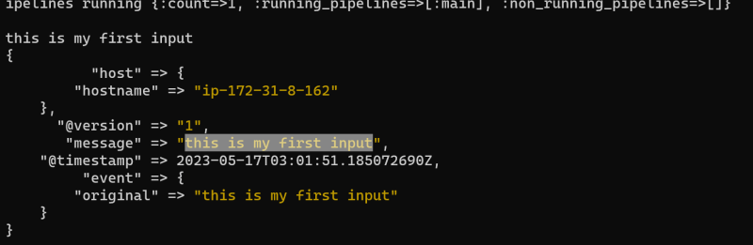
* Now lets the codec from rubydebug to json
* Edit first.conf with following content and start logstash sudo ./bin/logstash -f /tmp/first.conf

input {

stdin {

}

}

output {

stdout {

codec => json

}

}

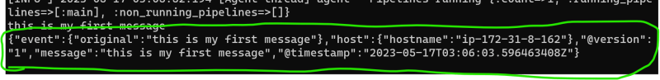  
* Lets add one more output to some file `stdout => codec => rubydebug  
* <https://www.elastic.co/guide/en/logstash/current/plugins-outputs-file.html> for file output plugin

input {

stdin {

}

}

output {

stdout {

}

file {

path => "/tmp/output%{+YYYY-MM-dd}.txt"

}

}

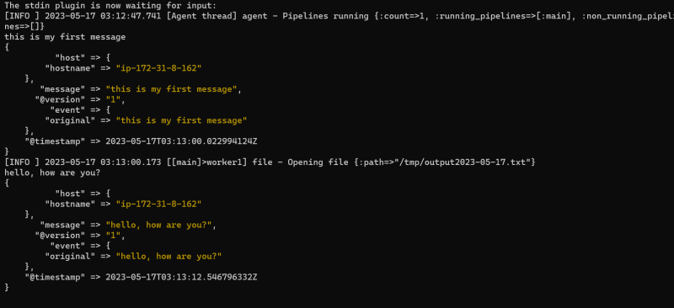  
* Open the file for contents  
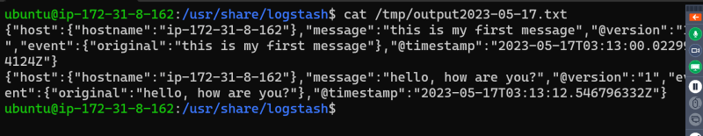

**Activity 2: Lets create a pipeline to read the file /tmp/test and display the contents in stdout**

* input = file
* output = stdout

input {

file {

path => ["/tmp/test"]

}

}

output {

stdout {

}

}

* install apache and redirect /var/log/apache2/access.log to stdout

input {

file {

path => ["/var/log/apache2/access.log"]

}

}

output {

stdout {

}

}

* Lets try to understand filters.
* Grok filter can parse unstructured data into fields <https://www.elastic.co/guide/en/logstash/current/plugins-filters-grok.html>